The PSCI’s support for the Musi River Revitalisation
22nd March 2022, World Water Day
The Pharmaceutical Supply Chain Initiative (PSCI) is pleased to continue supporting the work of the Telangana State Government to revitalize the Musi River. This statement provides an update one year on from our initial engagement with the project and showcases what has been achieved so far.

Background
The Musi River flows through Hyderabad in Telangana State, Southern India. It is fed by the world-heritage Hussein Sagar lake, also called the “heart of the world”, and used to be enjoyed by locals and tourists alike for its beauty and amenity. Yet, there have been numerous reports of polluted effluents and poor wastewater management practices affecting the lake and the Musi River watershed, impacting local communities over a period of many years.
To counter this, the State of Telangana has started an initiative to revitalize the area. The PSCI supports the efforts of the State of Telangana to reduce pollution of the Musi River (see our position statement).
For our part, the PSCI aims to use our influence to engage with suppliers of PSCI members in Telangana to promote better wastewater practices and encourage positive change. Our aim is that every single supplier with a connection to a PSCI member should be visited, audited or contacted directly to promote the best technologies for wastewater management.

Activities to date
In an initial phase, the PSCI has contacted suppliers in Hyderabad with a connection to our members and provided free capability building resources around wastewater treatment to improve suppliers’ practices. We have offered free access to our webinars which cover how to establish predicted environmental concentrations for API loss from pharma manufacturing, and risk assessment tools for discharge of Active Pharmaceutical Ingredients (APIs) in sludge and wastewater. Furthermore, our India supplier conference – which had more than 1300 attendees from 120 companies – included a dedicated session on wastewater treatment technologies. We have also offered a PEC:PNEC calculator tool for assessing API discharges. Finally, we recently supported the Industrial Green Chemistry World conference, hosted by the Green ChemisTree Foundation in January 2022, with speakers and content.
In a second phase, the PSCI created a baseline of all pharmaceutical companies in the Musi river catchment area and mapped which of these had connections to PSCI to understand the sphere of influence. Our aim is that all the suppliers to PSCI members should provide information about their wastewater treatment practices, either during a member visit, by questionnaire or (ideally) by providing a full site audit on PSCI’s audit sharing platform.
Out of 102 pharmaceutical and chemical companies identified in the region, 33 are suppliers to a PSCI member company (see figure below). At the date of World Water Day 2022, we have partial information on 32 of those suppliers, with full audits for 17.

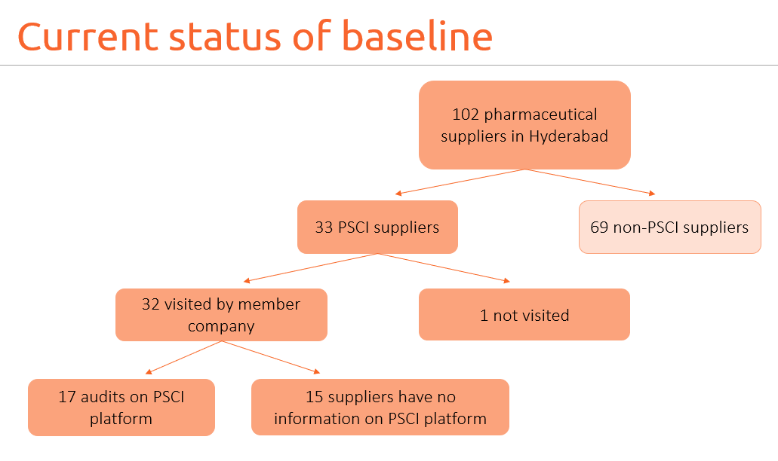
Figure 1: PSCI's pharmaceutical suppliers in the Musi river catchment area and number of suppliers that needed to be contacted

Next steps
We will continue to promote best practices in wastewater treatment and management to all our suppliers in India. We will also continue to conduct our supplier conferences and webinars to share knowledge and best practices.
We will continue to encourage suppliers to share audits and work with our members to encourage site visits or audits, especially for the one supplier for whom we have no data.
To fill the remaining gaps in our knowledge regarding suppliers’ wastewater management systems, the PSCI will offer audits free of charge to suppliers in the Musi River catchment. We will encourage suppliers to commission a third-party audit from a PSCI-qualified audit firm and, using the PSCI’s audit framework, share the results on our platform.
Whether a wastewater technology is appropriate and sufficient is often dependent on the specific activities of the suppliers and the maintenance and usage of the technologies. The PSCI has developed a tool (PEC:PNEC calculator) to determine whether a facility’s discharge of APIs is above or beyond an acceptable limit. We will promote this tool to all suppliers in Musi River catchment.
With these activities, the PSCI is hoping to contribute to restore the Musi River to its full former health and make a positive impact on peoples’ lives in the area.

